**Energy Management System**

**DISTRIBUTED SYSTEMS**

Ilies Oana-Elena

Calculatoare, an IV, 30244

Diagrama de deployment

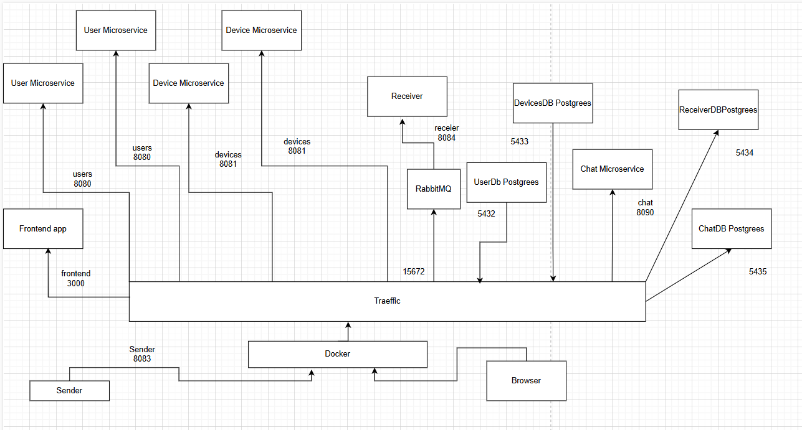

Diagrama conceputala

